**Control System Lab #03**



**FALL 2023**

Submitted by: **Safi Ullah Khan**

Registration : **20PWCSE1943** Class Section: **B**

“On my honor, as student of University of Engineering and Technology, I have neither given nor received unauthorized assistance on this academic work.”

Student Signature:

Submitted to:

Engr. Dr. Muniba Ashfaq

Task1:

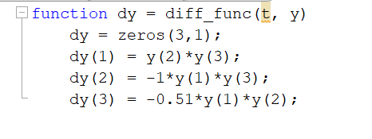

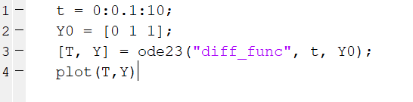

## output:

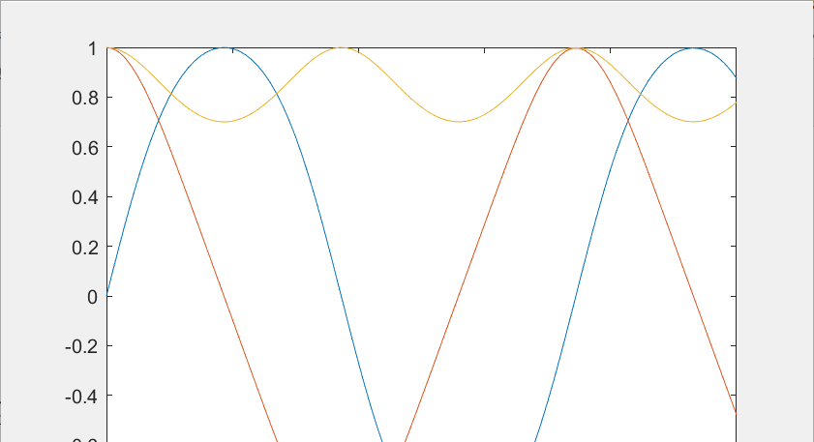

Task2:

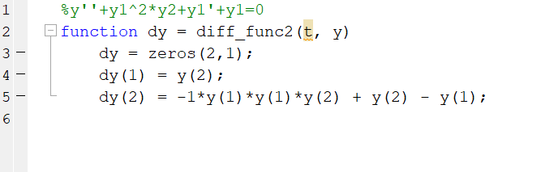

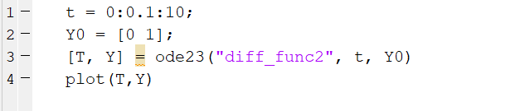

**Output:**

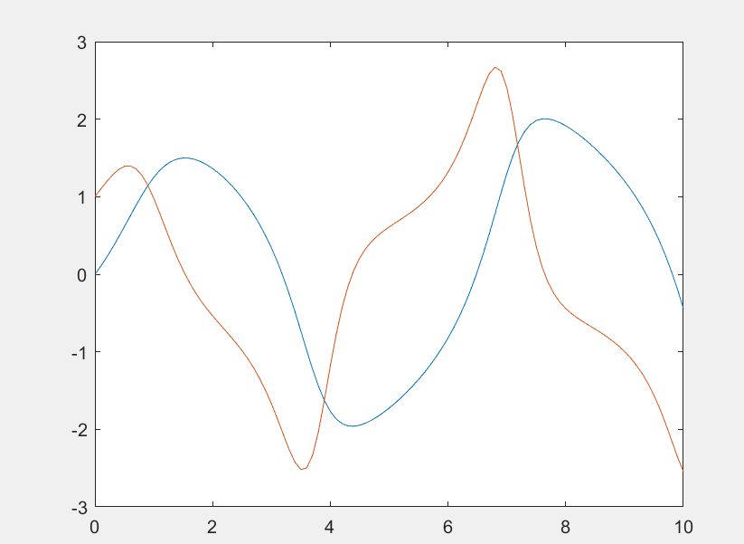

Task3:

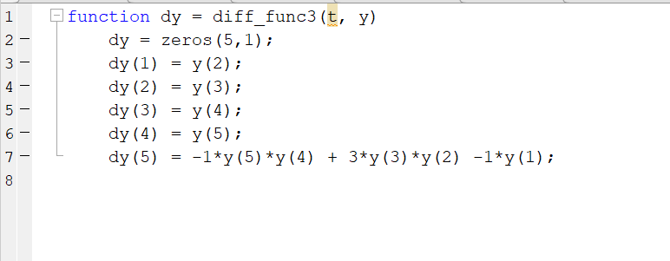

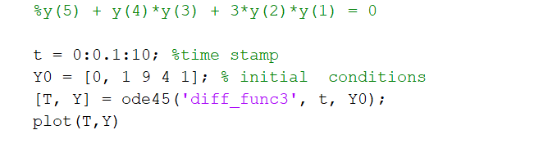

## Output:

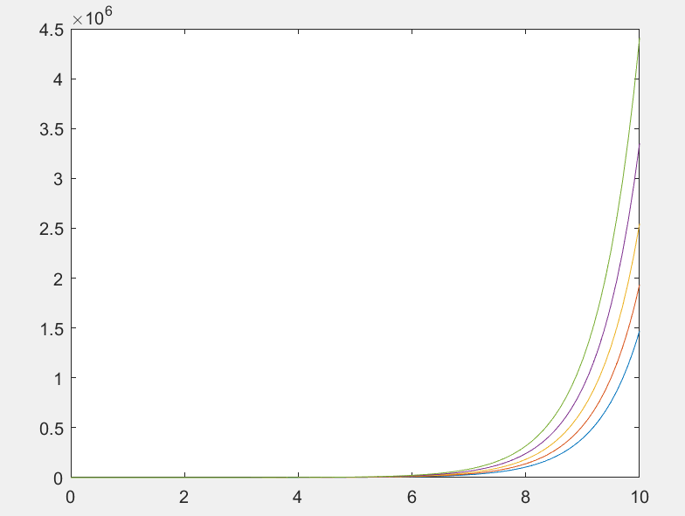

**Conclusions:**

we employed differential equations to model a dynamic system and visualized the results using MATLAB. The differential equations served as powerful tools to describe how various factors and variables interacted within the system over time.. The resulting plots and graphs generated using MATLAB provided valuable insights into the system's behavior and allowed us to draw meaningful conclusions about its dynamics.